5.79: If the plane is flying at a constant speed of 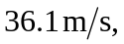 then 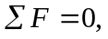 or 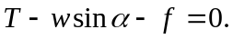 The rate of climb and the speed give the angle 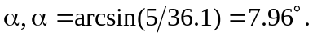 Then, Note that in level flight 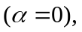 the thrust only needs to overcome the drag force to maintain the constant speed of 